Analyzing Photography
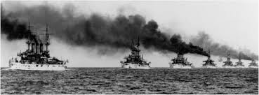
The Great White Fleet, 1907, USS Kansas Leads the Way
Level 1 – Basic Analysis
- Who or what do you see?

- When was this photograph taken — what is happening in the photograph?

- Where was this photograph taken?

Level 2 – Intermediate Analysis
- Why did the photographer select these particular elements to include in the photograph?

- What don’t you see?

- Why did the photographer emphasize certain elements and not others? What’s in focus?

- Is only one person or element in focus, or are many elements in focus?

- Why did the photographer take the picture at this moment? What happened before or after this picture was taken?

- Why did the photographer take the picture from this angle? What might the scene have looked like from another vantage point — from left, right, behind, above, or below?

Level 3 – Deep Analysis

- What else do I need to know about this time period?

- How could this picture depict the expansion of presidential power?

- If I had to compare this picture to another, how would I do that?

- Tell me about this photo…
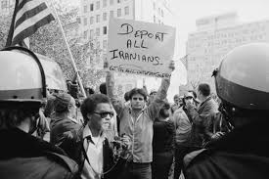
Americans protesting the Iranian Hostage Crisis (1979)
Level 1 – Basic Analysis
- Who or what do you see?

- When was this photograph taken — what is happening in the photograph?

- Where was this photograph taken?

Level 2 – Intermediate Analysis
- Why did the photographer select these particular elements to include in the photograph?

- What don’t you see?

- Why did the photographer emphasize certain elements and not others? What’s in focus?

- Is only one person or element in focus, or are many elements in focus?

- Why did the photographer take the picture at this moment? What happened before or after this picture was taken?

- Why did the photographer take the picture from this angle? What might the scene have looked like from another vantage point — from left, right, behind, above, or below?

Level 3 – Deep Analysis

- What else do I need to know about this time period?

- How could this picture depict the expansion of presidential power?

- If I had to compare this picture to another, how would I do that?

- Tell me about this photo…
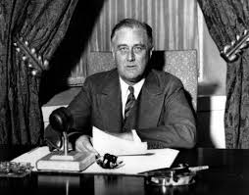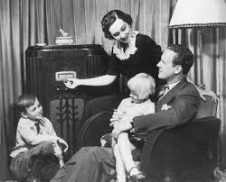
Left: FDR, “The Banking Crisis,” Fireside Chats 1933 Right: 1934 Family Listens to Fireside Chats
Level 1 – Basic Analysis
- Who or what do you see?

- When was this photograph taken — what is happening in the photograph?

- Where was this photograph taken?

Level 2 – Intermediate Analysis
- Why did the photographer select these particular elements to include in the photograph?

- What don’t you see?

- Why did the photographer emphasize certain elements and not others? What’s in focus?

- Is only one person or element in focus, or are many elements in focus?

- Why did the photographer take the picture at this moment? What happened before or after this picture was taken?

- Why did the photographer take the picture from this angle? What might the scene have looked like from another vantage point — from left, right, behind, above, or below?

Level 3 – Deep Analysis

- What else do I need to know about this time period?

- How could this picture depict the expansion of presidential power?

- If I had to compare this picture to another, how would I do that?

- Tell me about this photo…

