Does the President of the United States have too Much Power?
Day 1: Political Cartoon Analysis

Directions: Use the following political cartoon to answer the questions about presidential power.

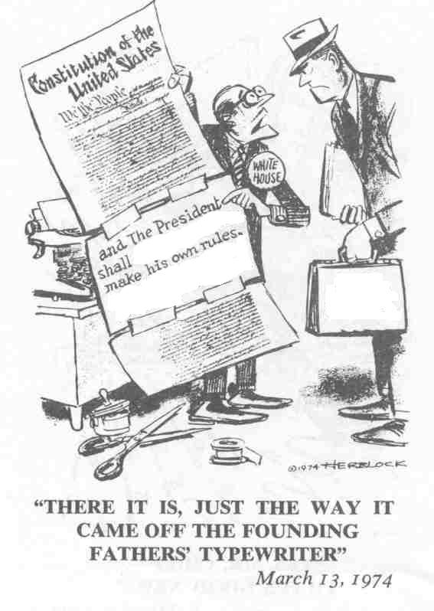

- What objects do you see? Which of them are symbols? What does each symbol mean?

- What words are in the cartoon? Which words or phrases in the cartoon appear the most significant? Why do you think so?

- List 3 adjectives that describe the emotions presented in the cartoon.

- Describe the action taking place in the cartoon.

- What message is the artist trying to convey? What message is the cartoon implying about the powers of the President?

